Table of Contents

A) IDLE: Generator Bus Voltage 2

A) IDLE: Active Power 3

A) IDLE: Reactive Power 4

A) IDLE: Generator Stator Current 5

A) IDLE: Excitation Voltage 6

A) IDLE: Excitation Current 7

A) IDLE: Generator Speed 8

A) IDLE: Gen. Frequency Deviation 9

A) IDLE: Ext. Rotor Angle 10

A) IDLE: Int. Rotor Angle 11

B) ZERO GEN. POWER: Generator Bus Voltage 12

B) ZERO GEN. POWER: Active Power 13

B) ZERO GEN. POWER: Reactive Power 14

B) ZERO GEN. POWER: Generator Stator Current 15

B) ZERO GEN. POWER: Excitation Voltage 16

B) ZERO GEN. POWER: Excitation Current 17

B) ZERO GEN. POWER: Generator Speed 18

B) ZERO GEN. POWER: Gen. Frequency Deviation 19

B) ZERO GEN. POWER: Ext. Rotor Angle 20

B) ZERO GEN. POWER: Int. Rotor Angle 21

C) NOMINAL GEN. ACT. POWER: Generator Bus Voltage 22

C) NOMINAL GEN. ACT. POWER: Active Power 23

C) NOMINAL GEN. ACT. POWER: Reactive Power 24

C) NOMINAL GEN. ACT. POWER: Generator Stator Current 25

C) NOMINAL GEN. ACT. POWER: Excitation Voltage 26

C) NOMINAL GEN. ACT. POWER: Excitation Current 27

C) NOMINAL GEN. ACT. POWER: Generator Speed 28

C) NOMINAL GEN. ACT. POWER: Gen. Frequency Deviation 29

C) NOMINAL GEN. ACT. POWER: Ext. Rotor Angle 30

C) NOMINAL GEN. ACT. POWER: Int. Rotor Angle 31

# A) IDLE: Generator Bus Voltage

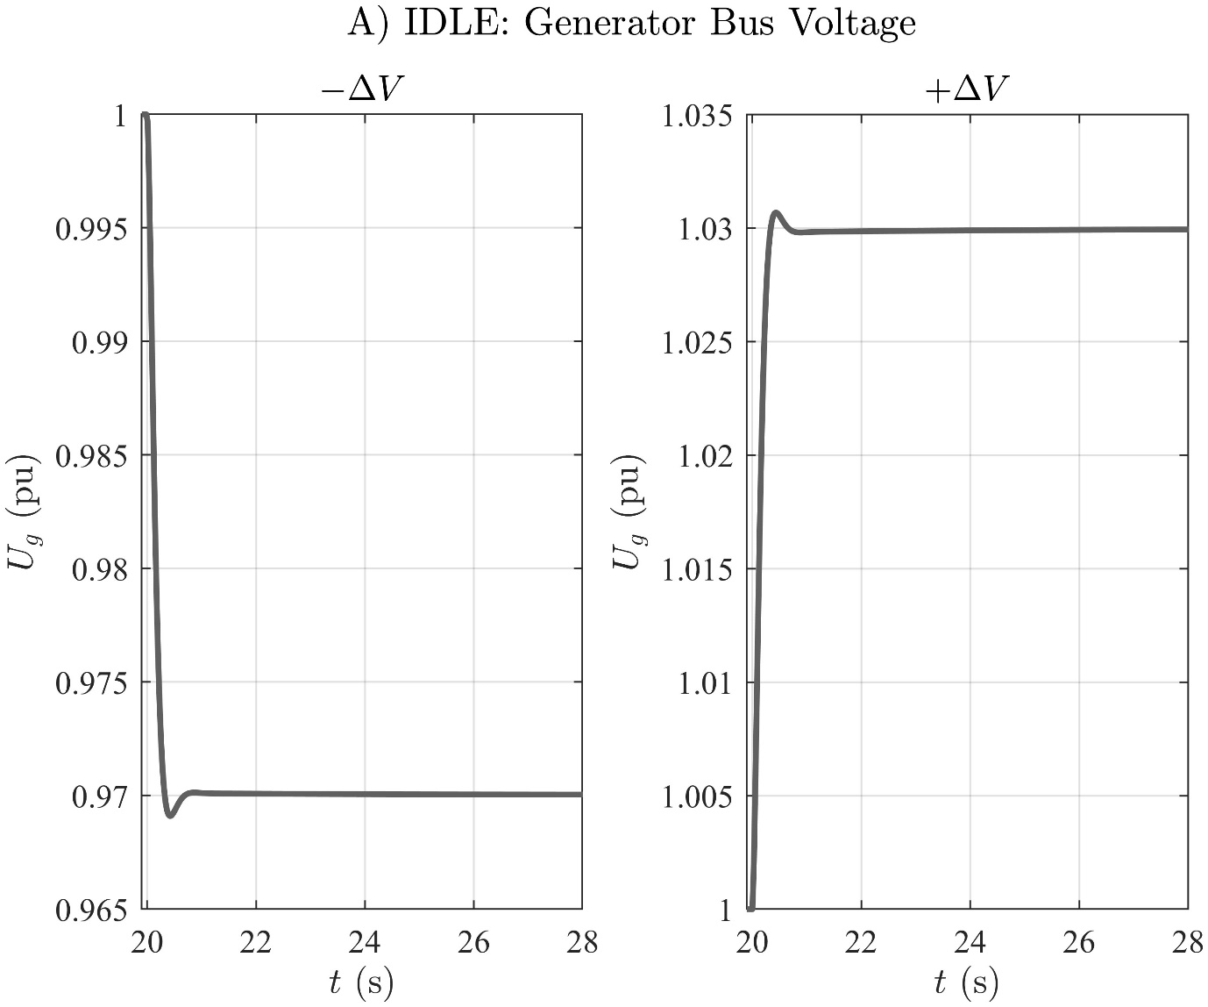

# A) IDLE: Active Power

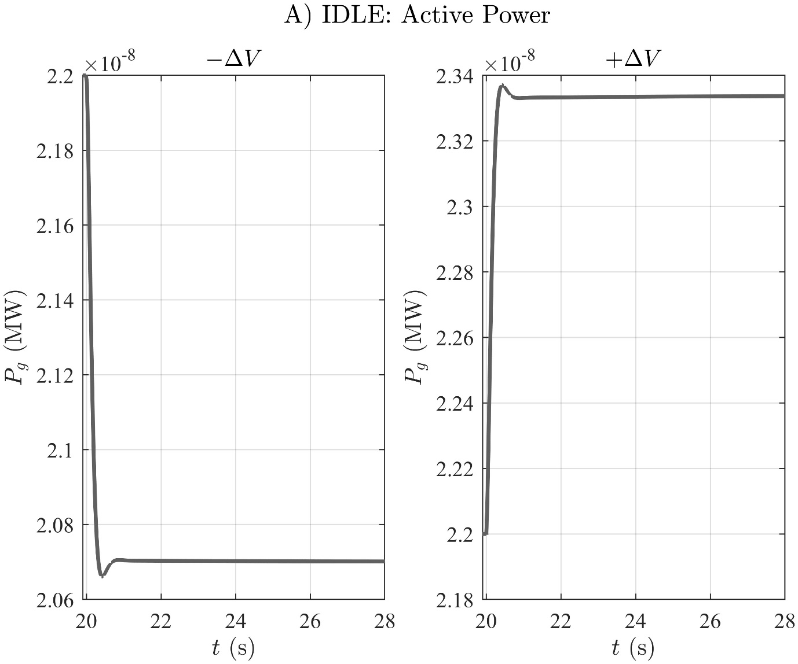

# A) IDLE: Reactive Power

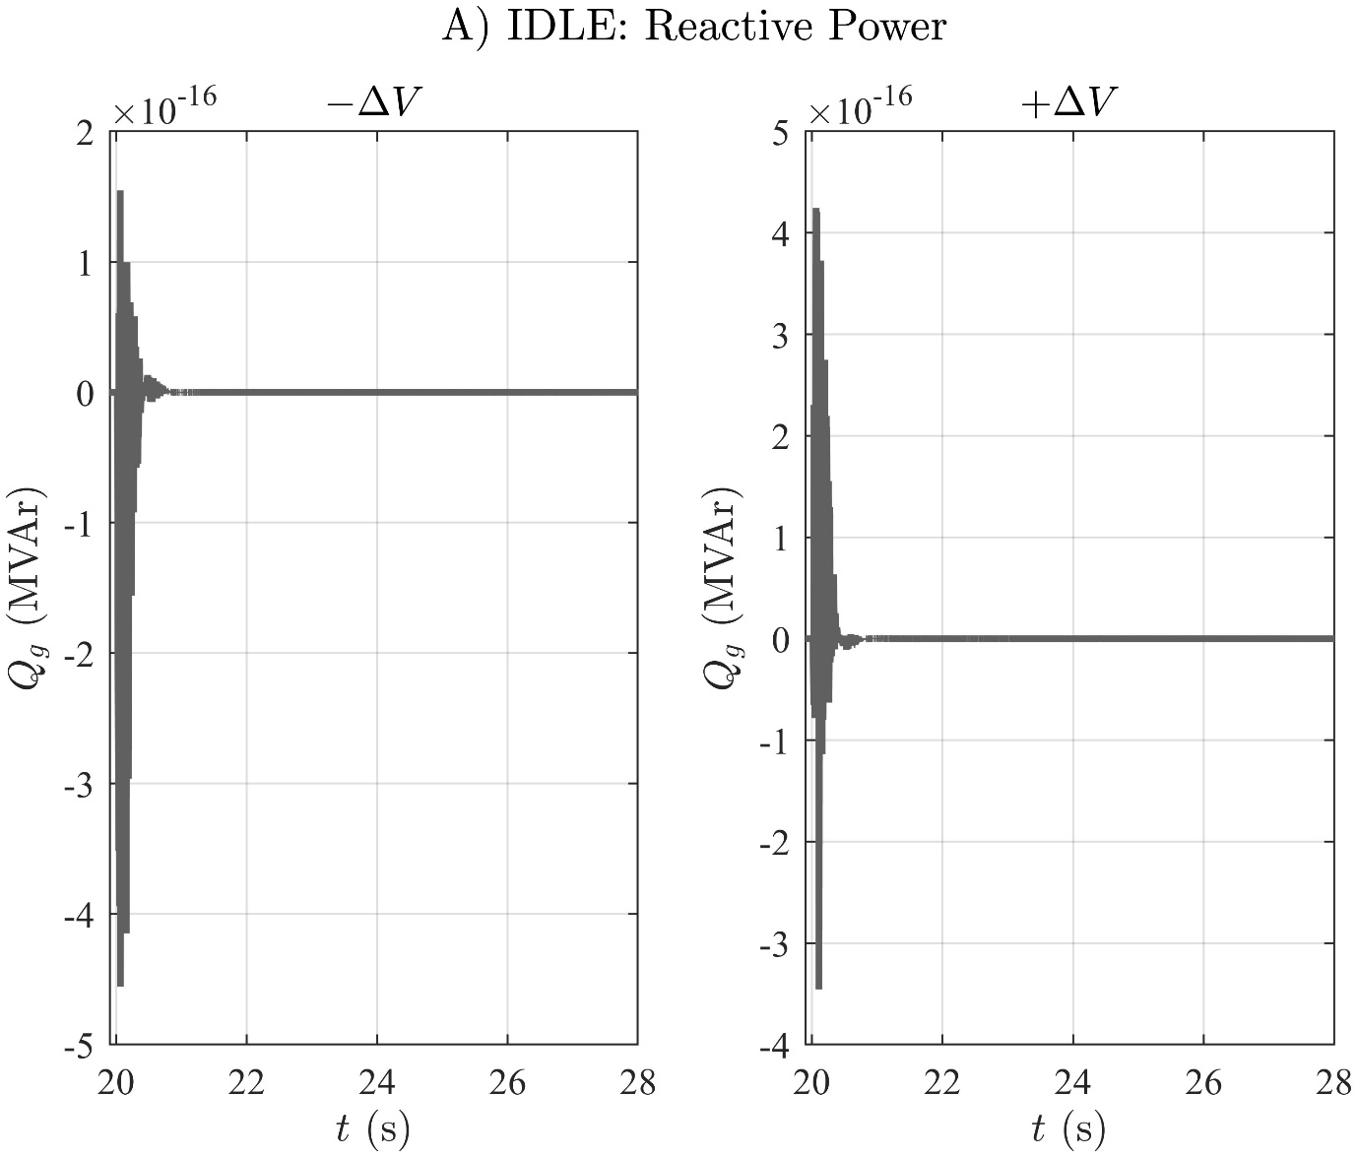

# A) IDLE: Generator Stator Current

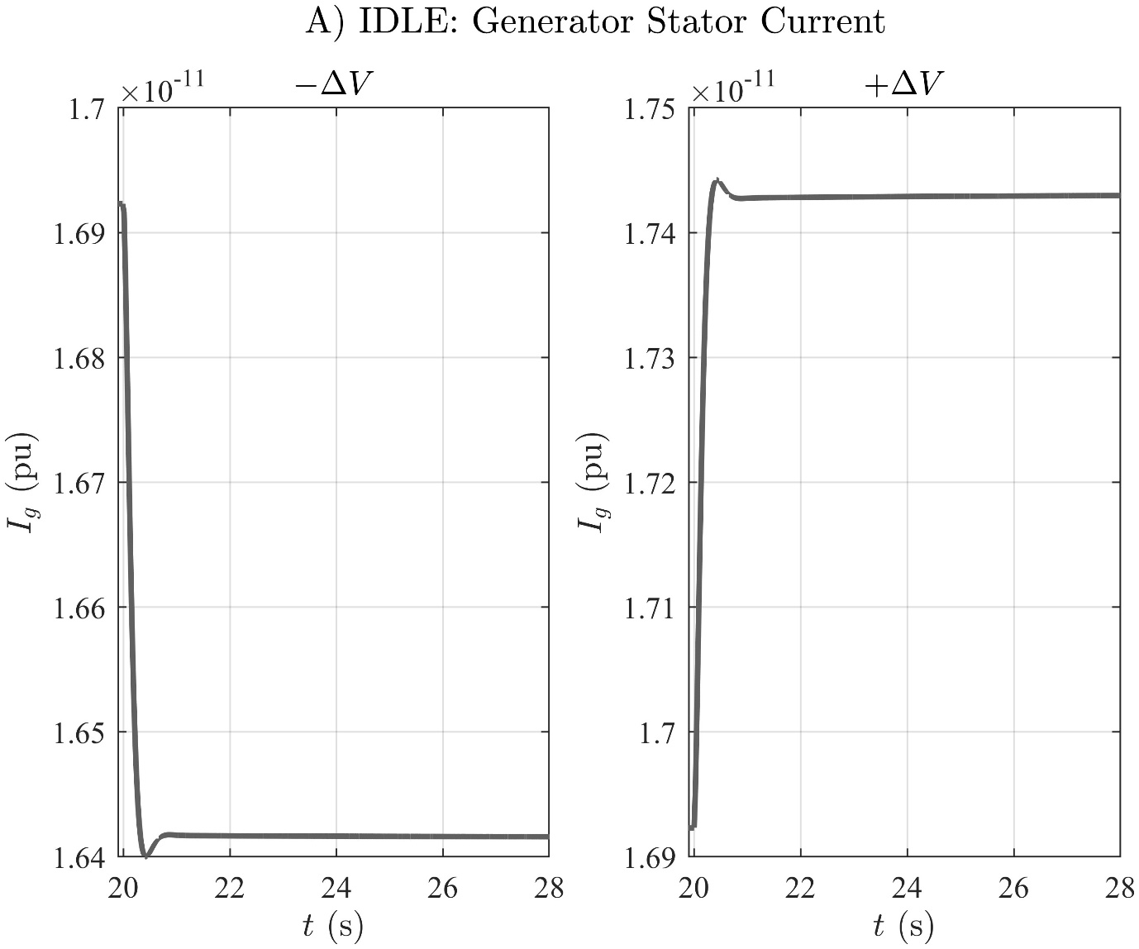

# A) IDLE: Excitation Voltage

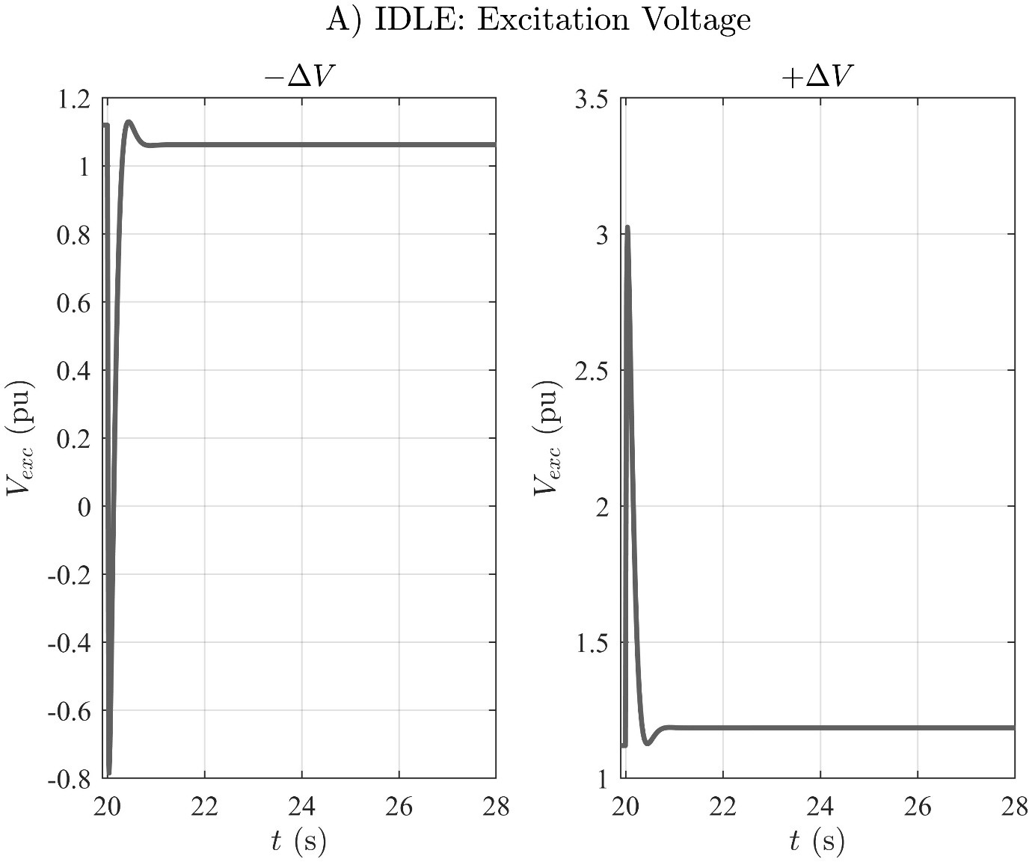

# A) IDLE: Excitation Current

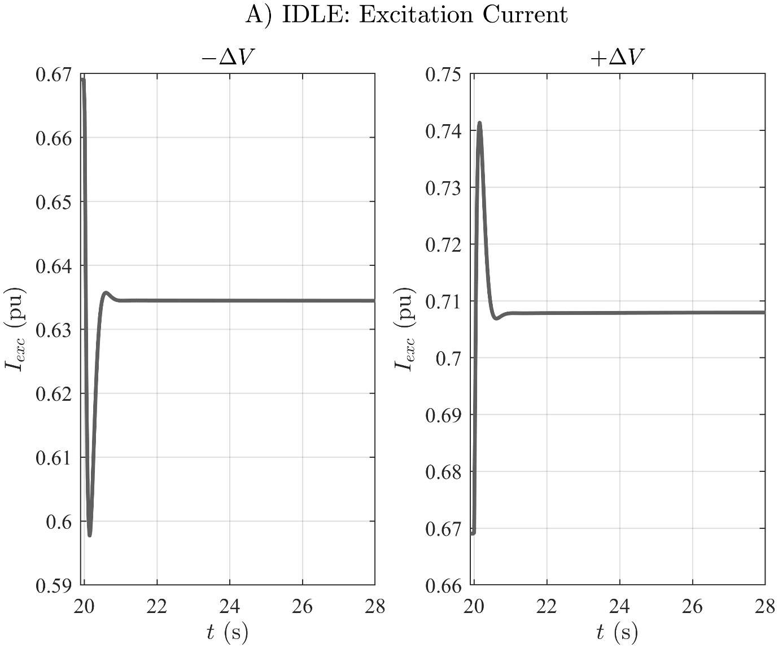

# A) IDLE: Generator Speed

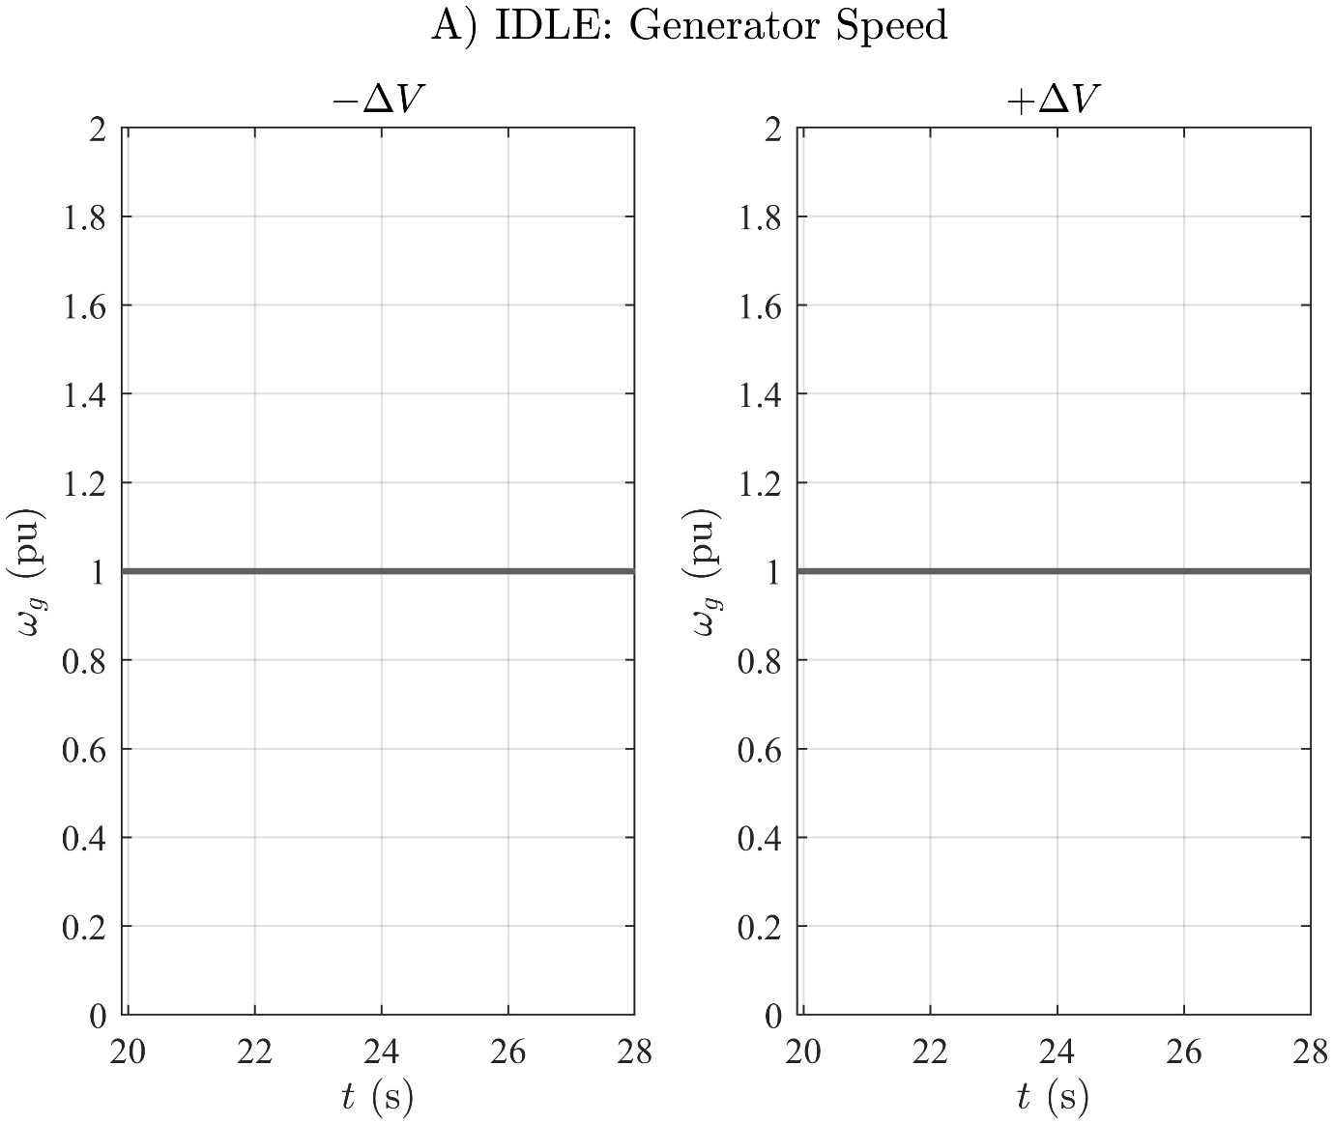

# A) IDLE: Gen. Frequency Deviation

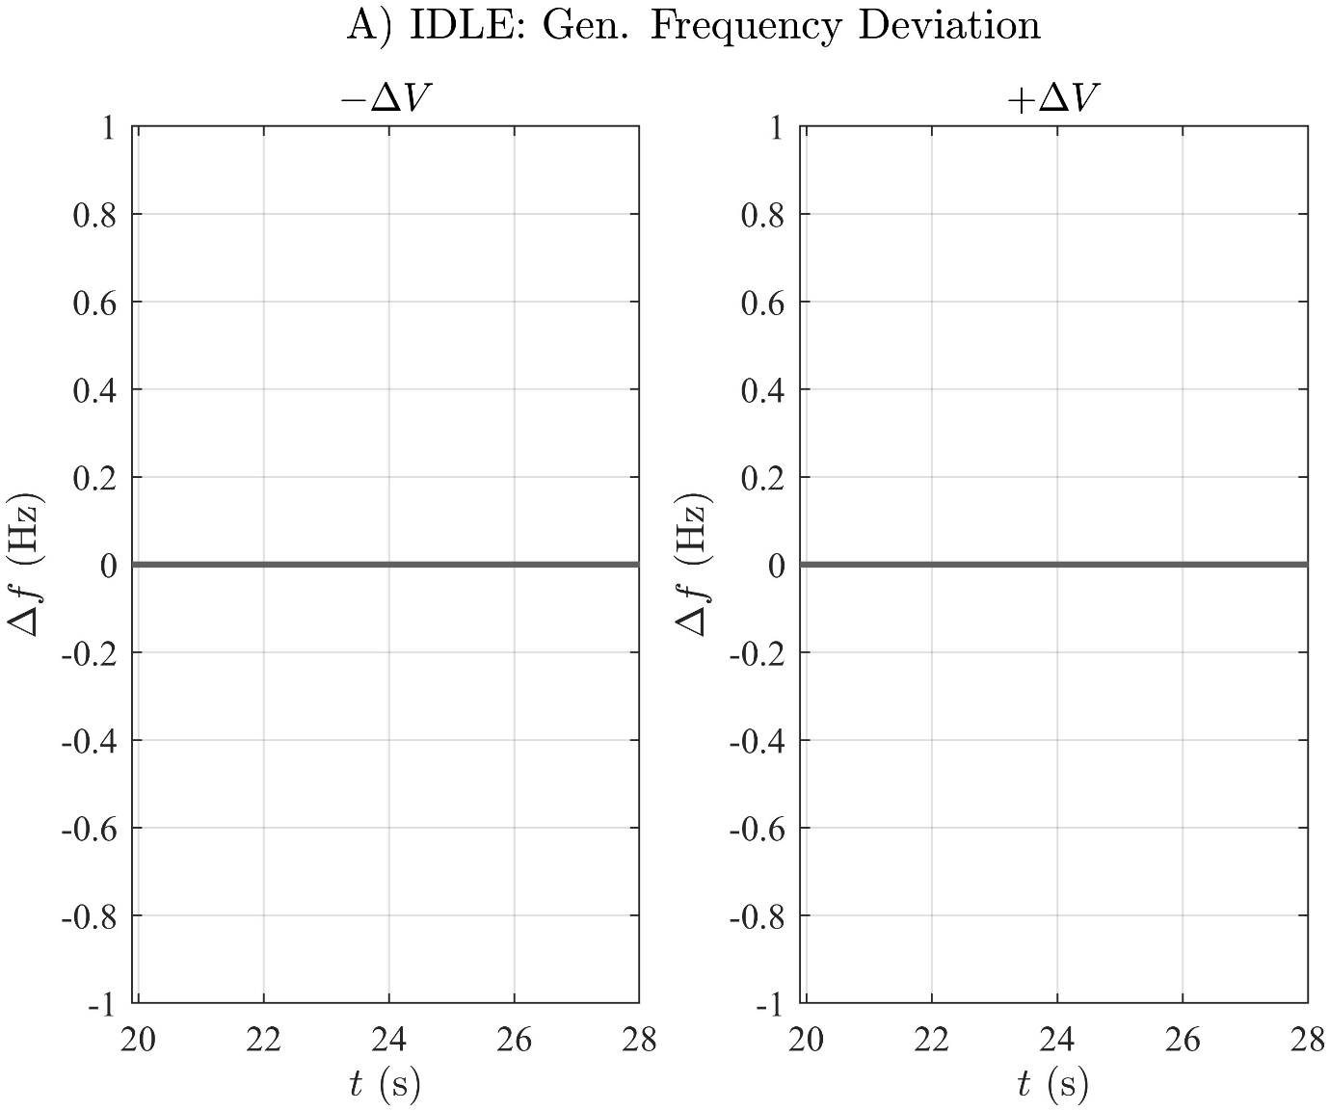

# A) IDLE: Ext. Rotor Angle

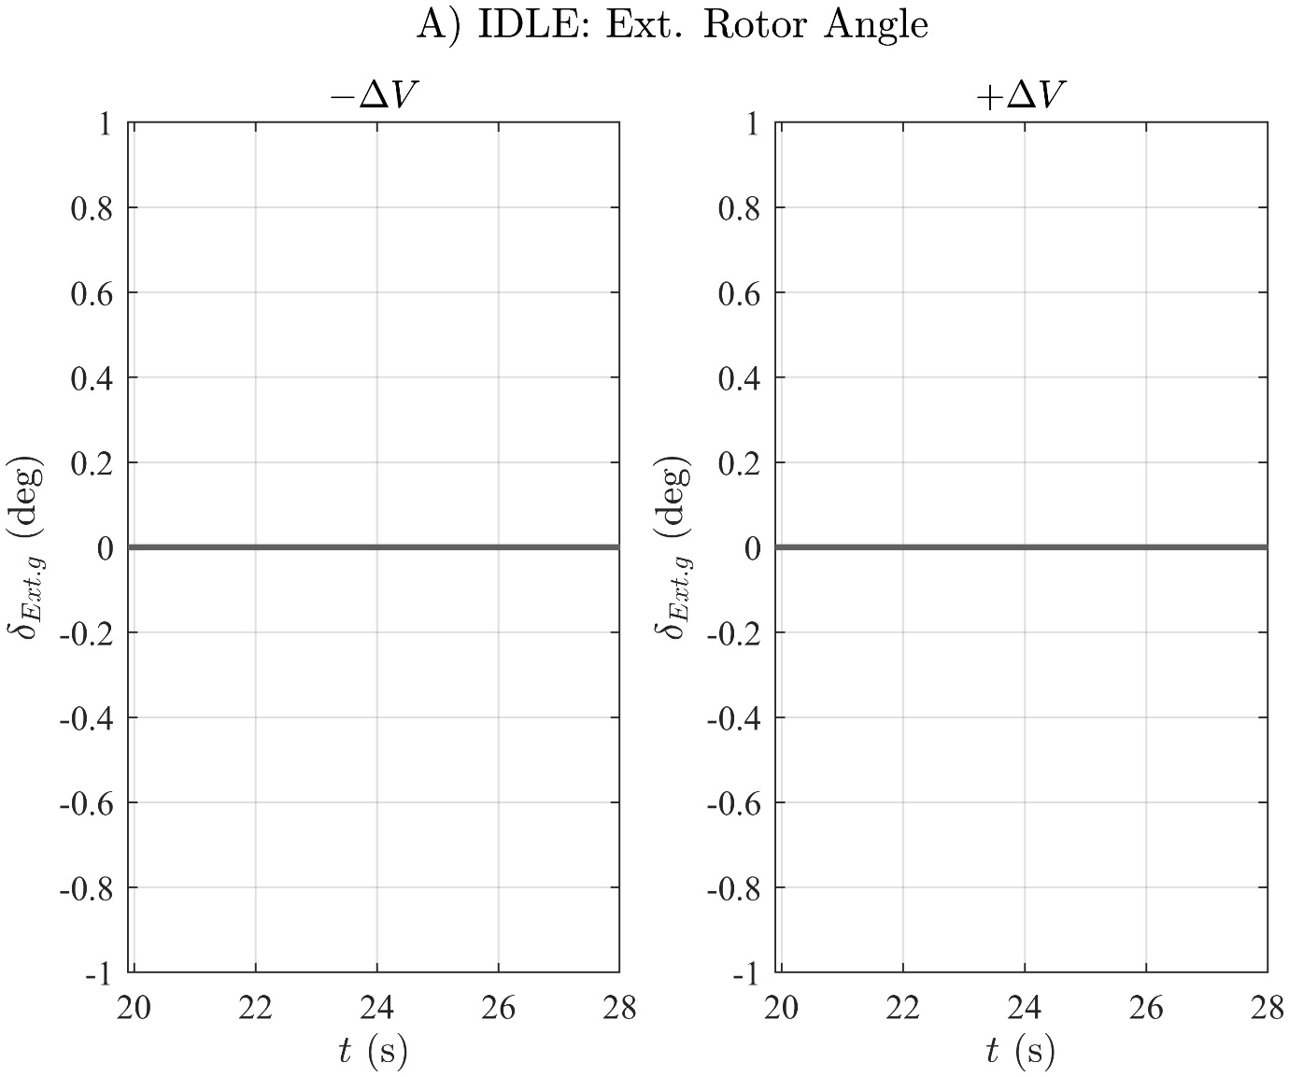

# A) IDLE: Int. Rotor Angle

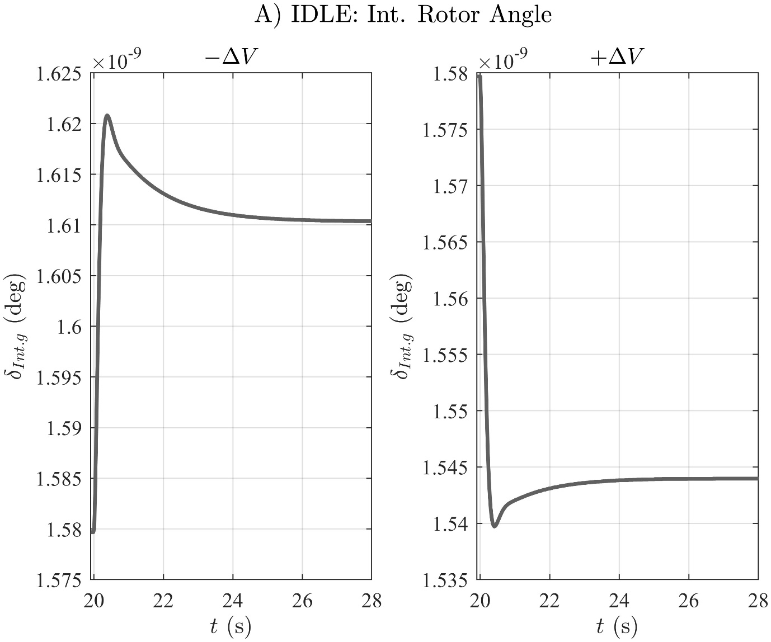

# B) ZERO GEN. POWER: Generator Bus Voltage

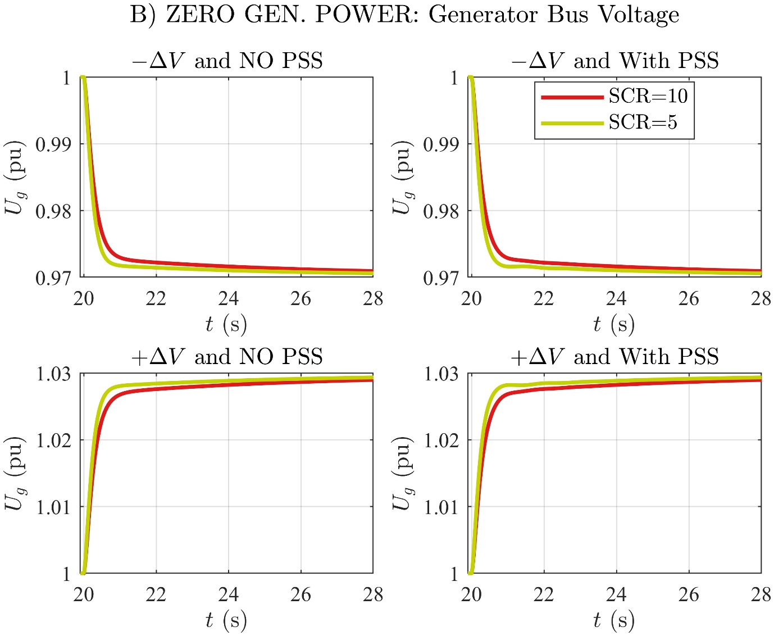

# B) ZERO GEN. POWER: Active Power

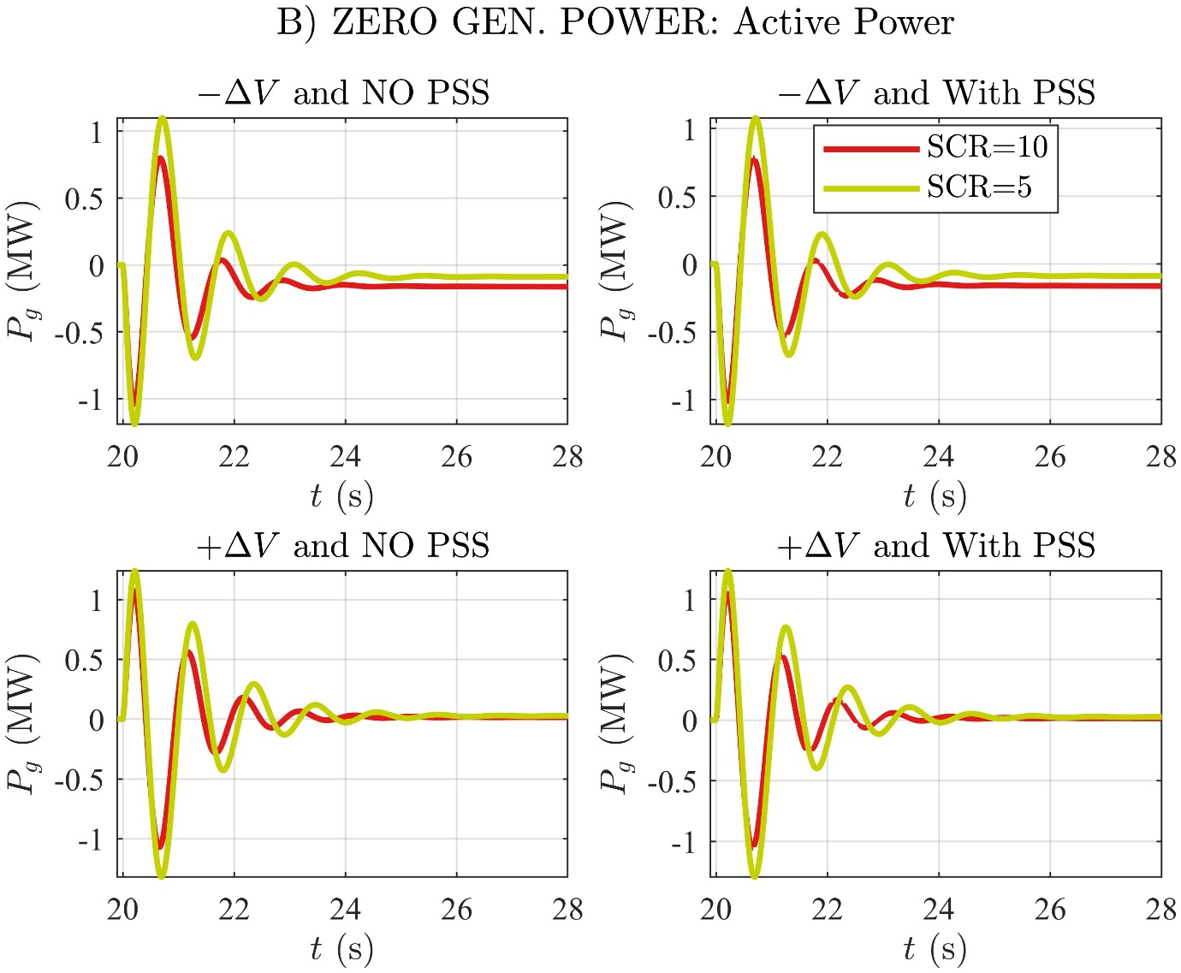

# B) ZERO GEN. POWER: Reactive Power

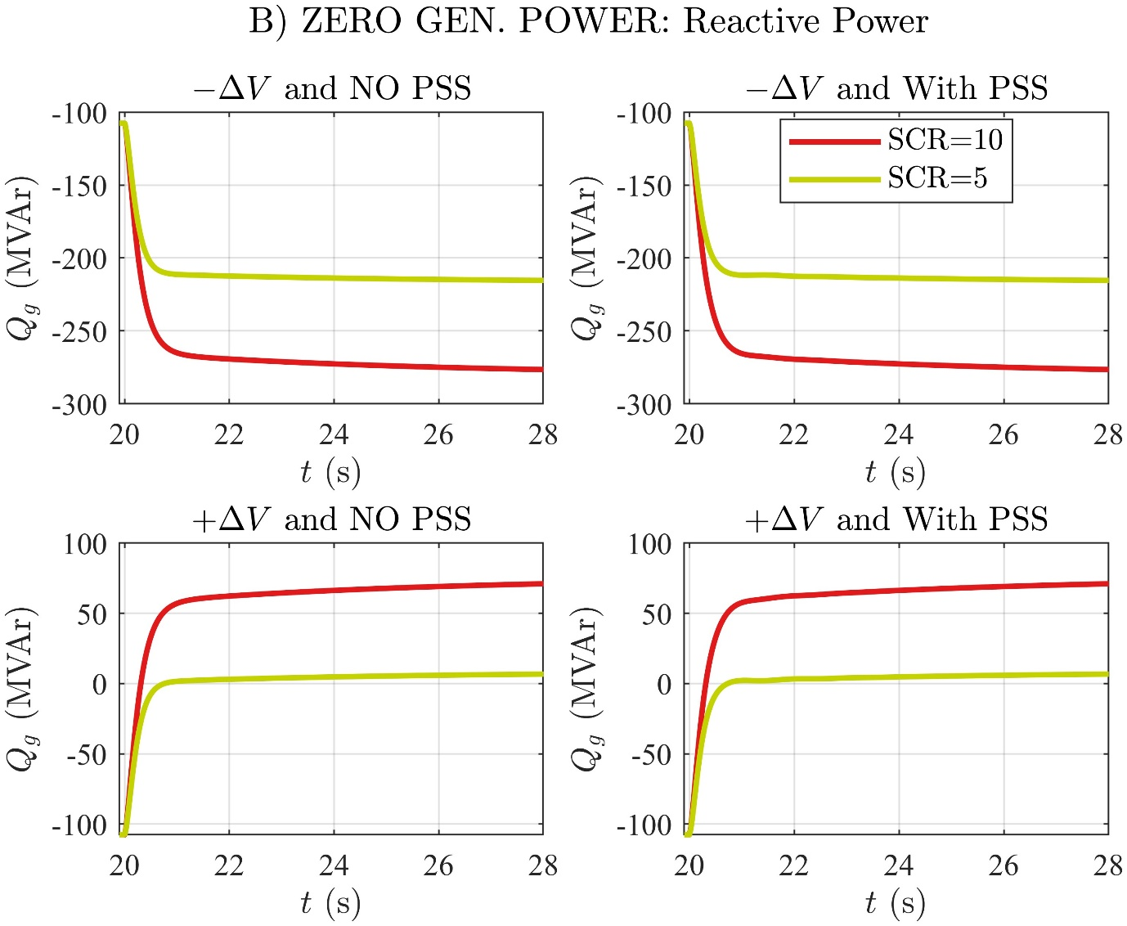

# B) ZERO GEN. POWER: Generator Stator Current

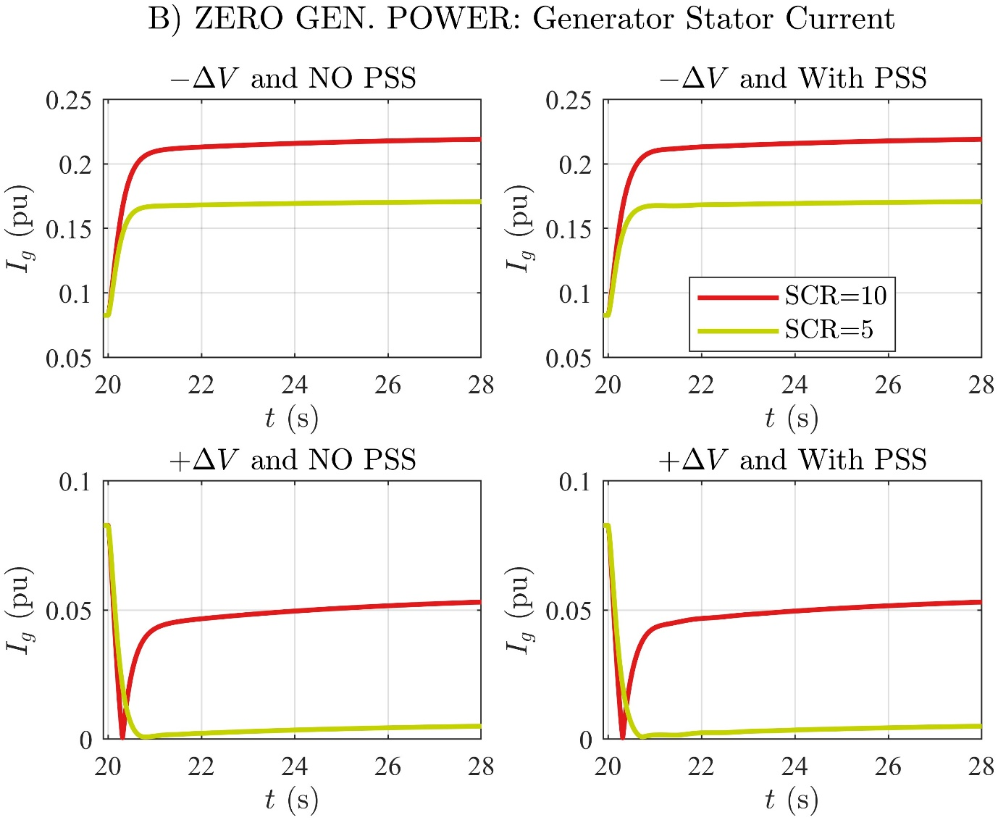

# B) ZERO GEN. POWER: Excitation Voltage

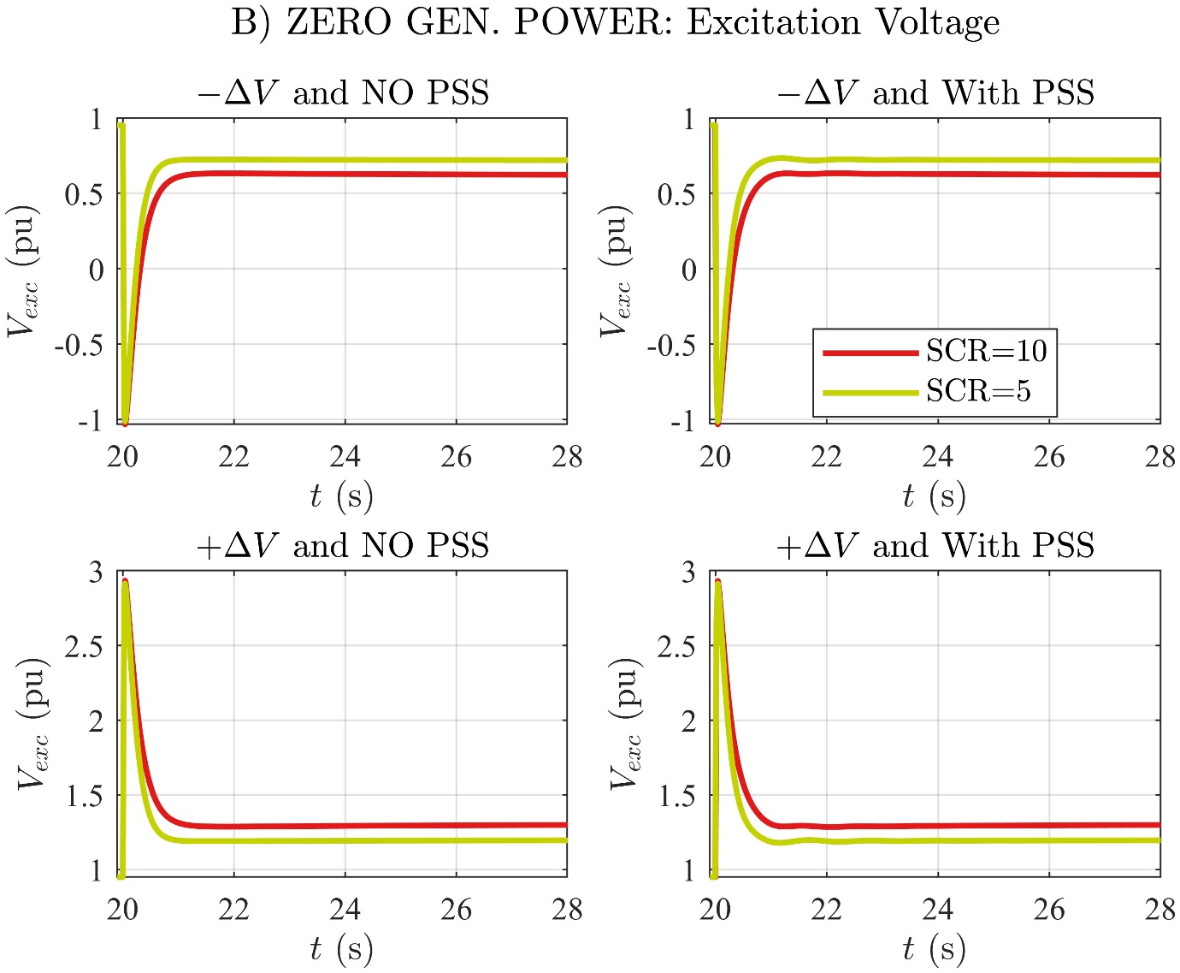

# B) ZERO GEN. POWER: Excitation Current

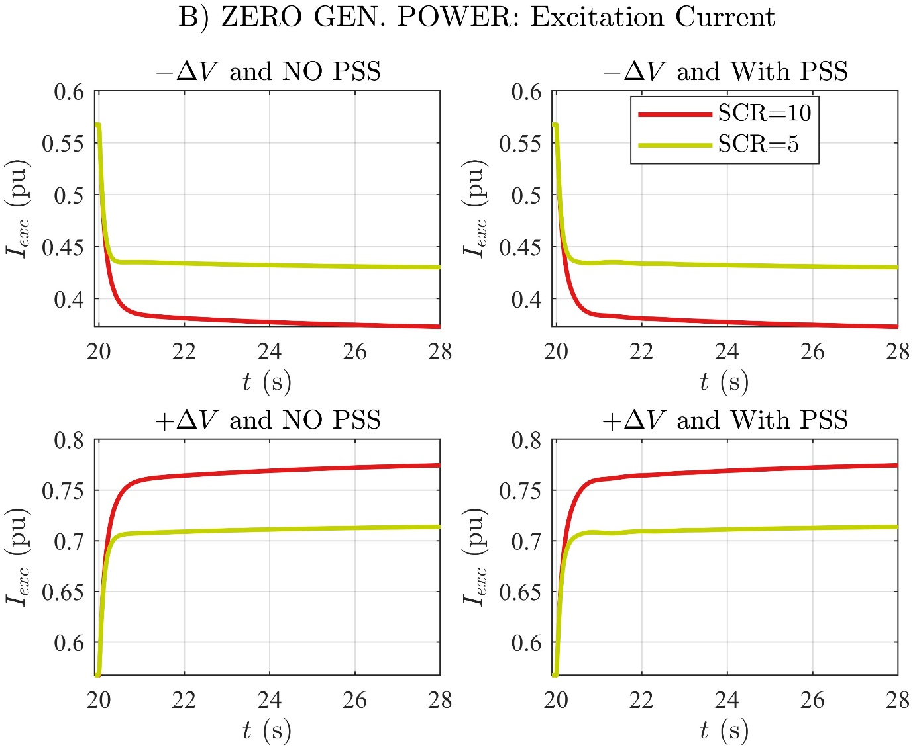

# B) ZERO GEN. POWER: Generator Speed

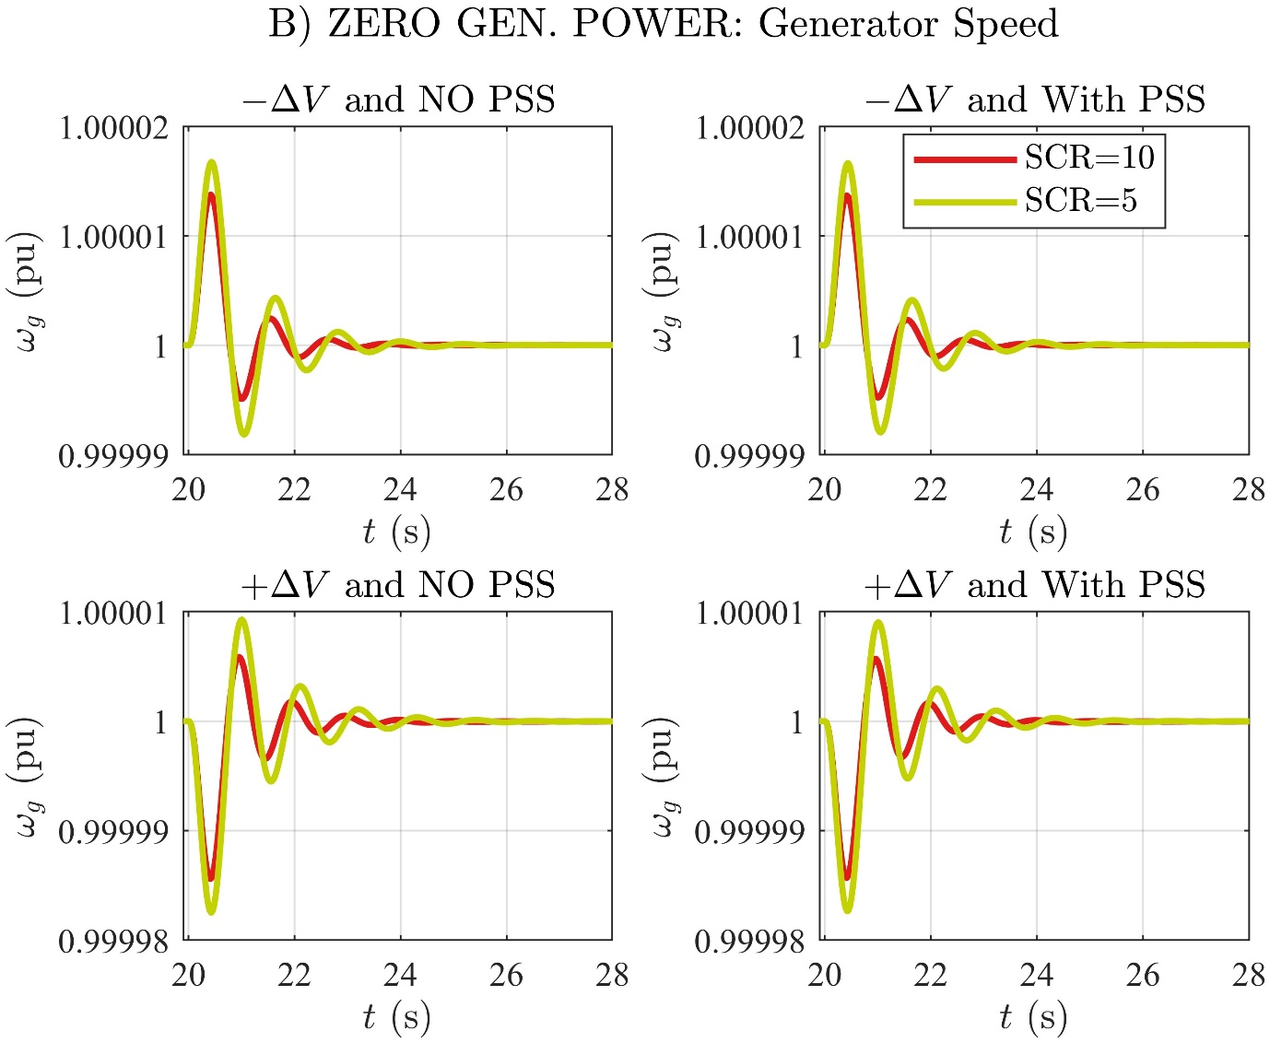

# B) ZERO GEN. POWER: Gen. Frequency Deviation

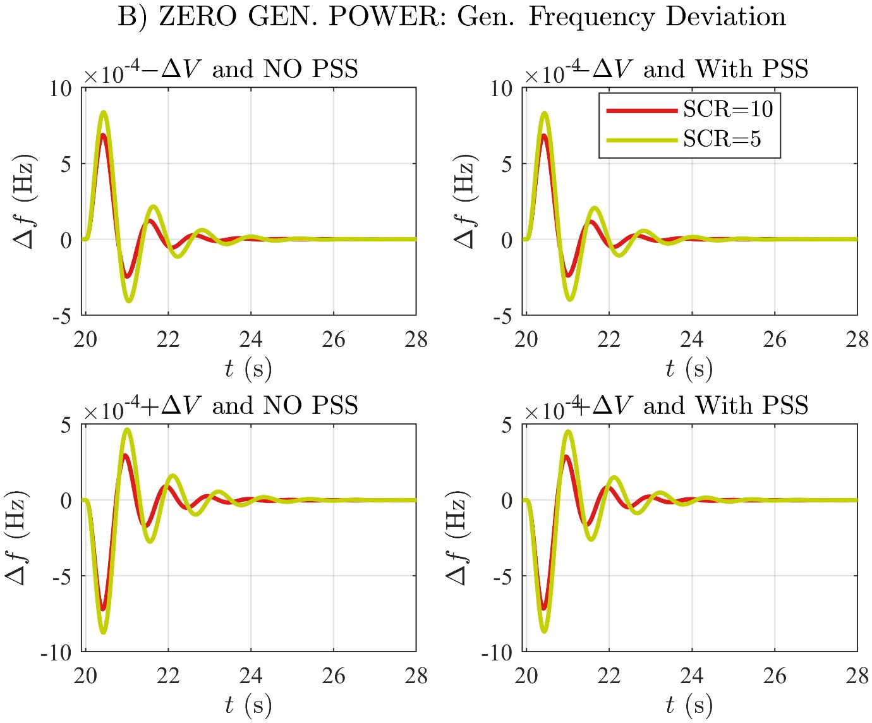

# B) ZERO GEN. POWER: Ext. Rotor Angle

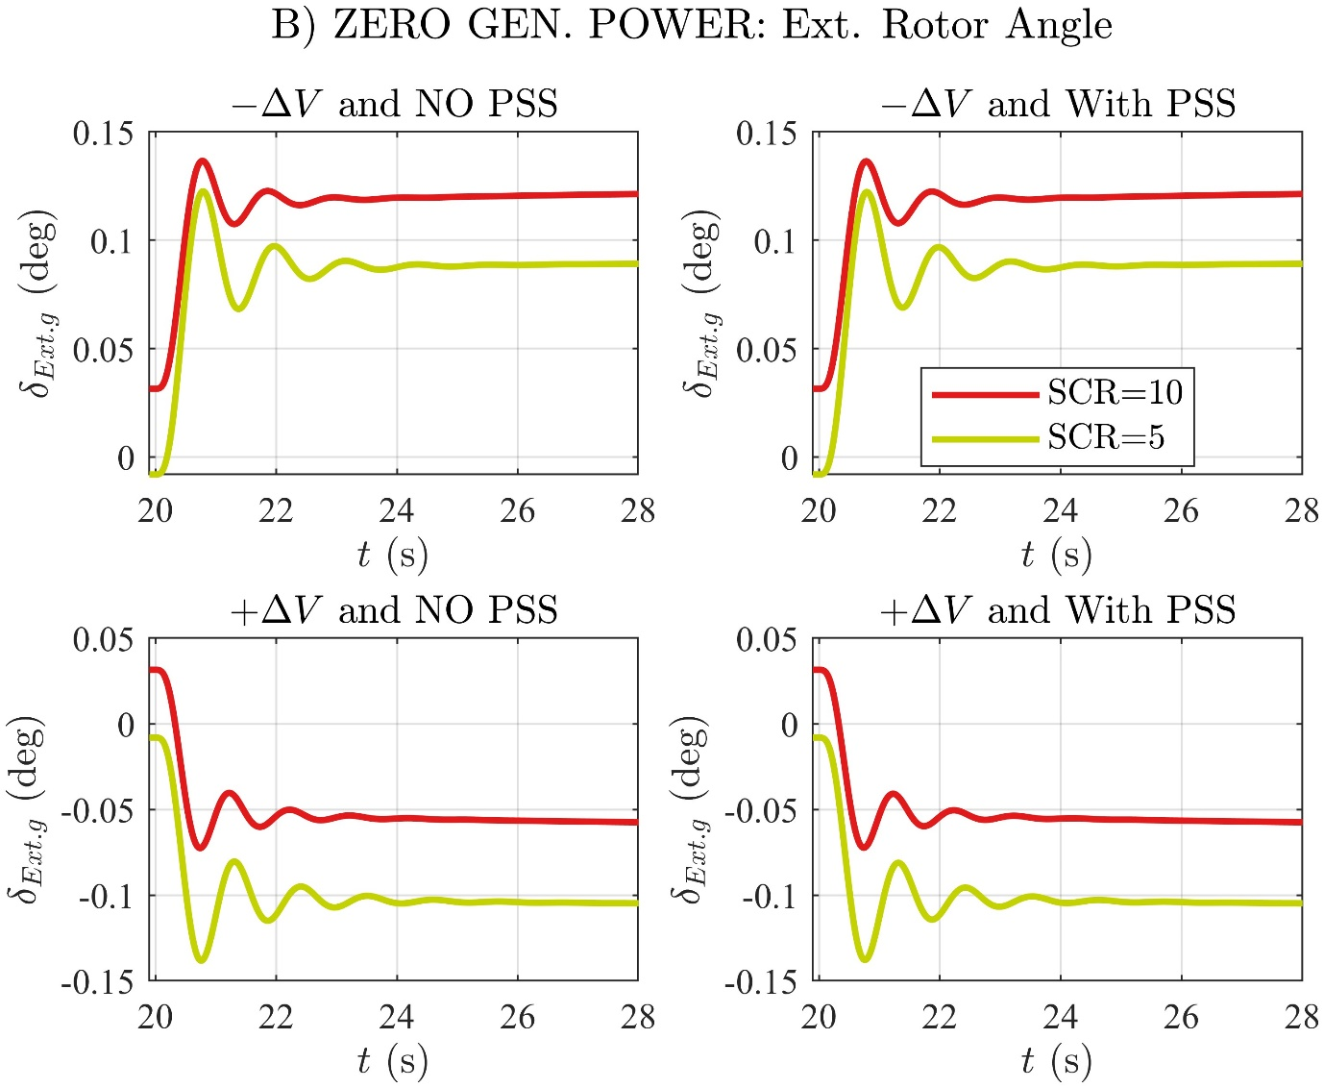

# B) ZERO GEN. POWER: Int. Rotor Angle

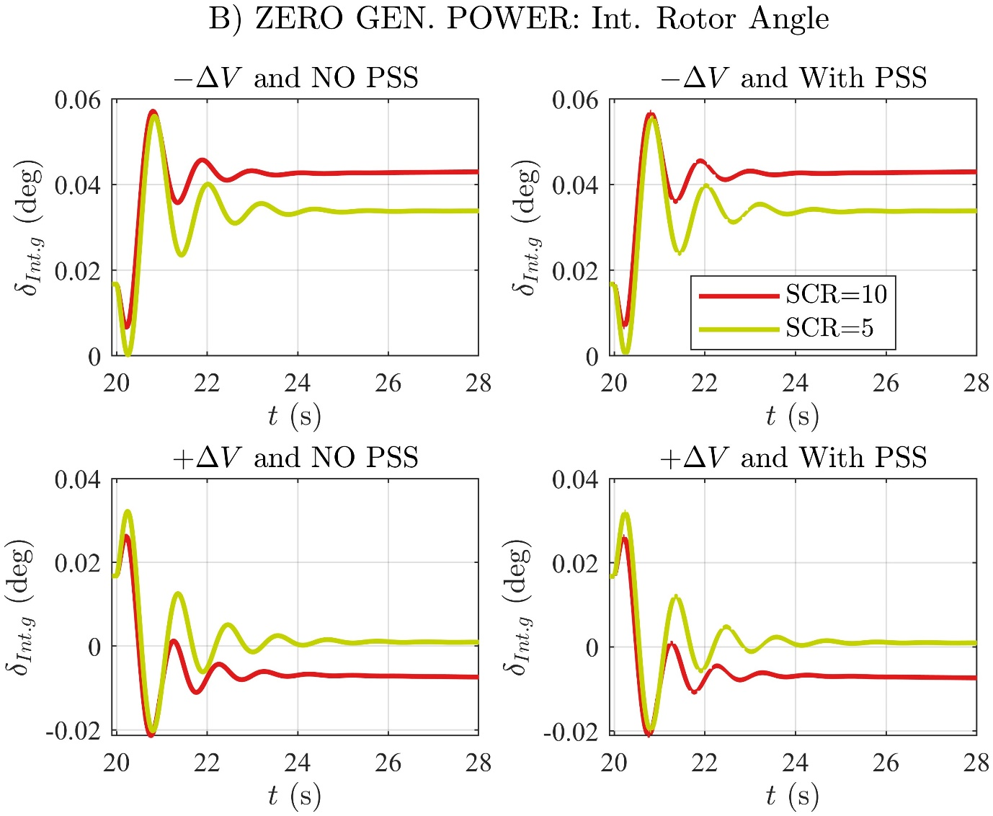

# C) NOMINAL GEN. ACT. POWER: Generator Bus Voltage

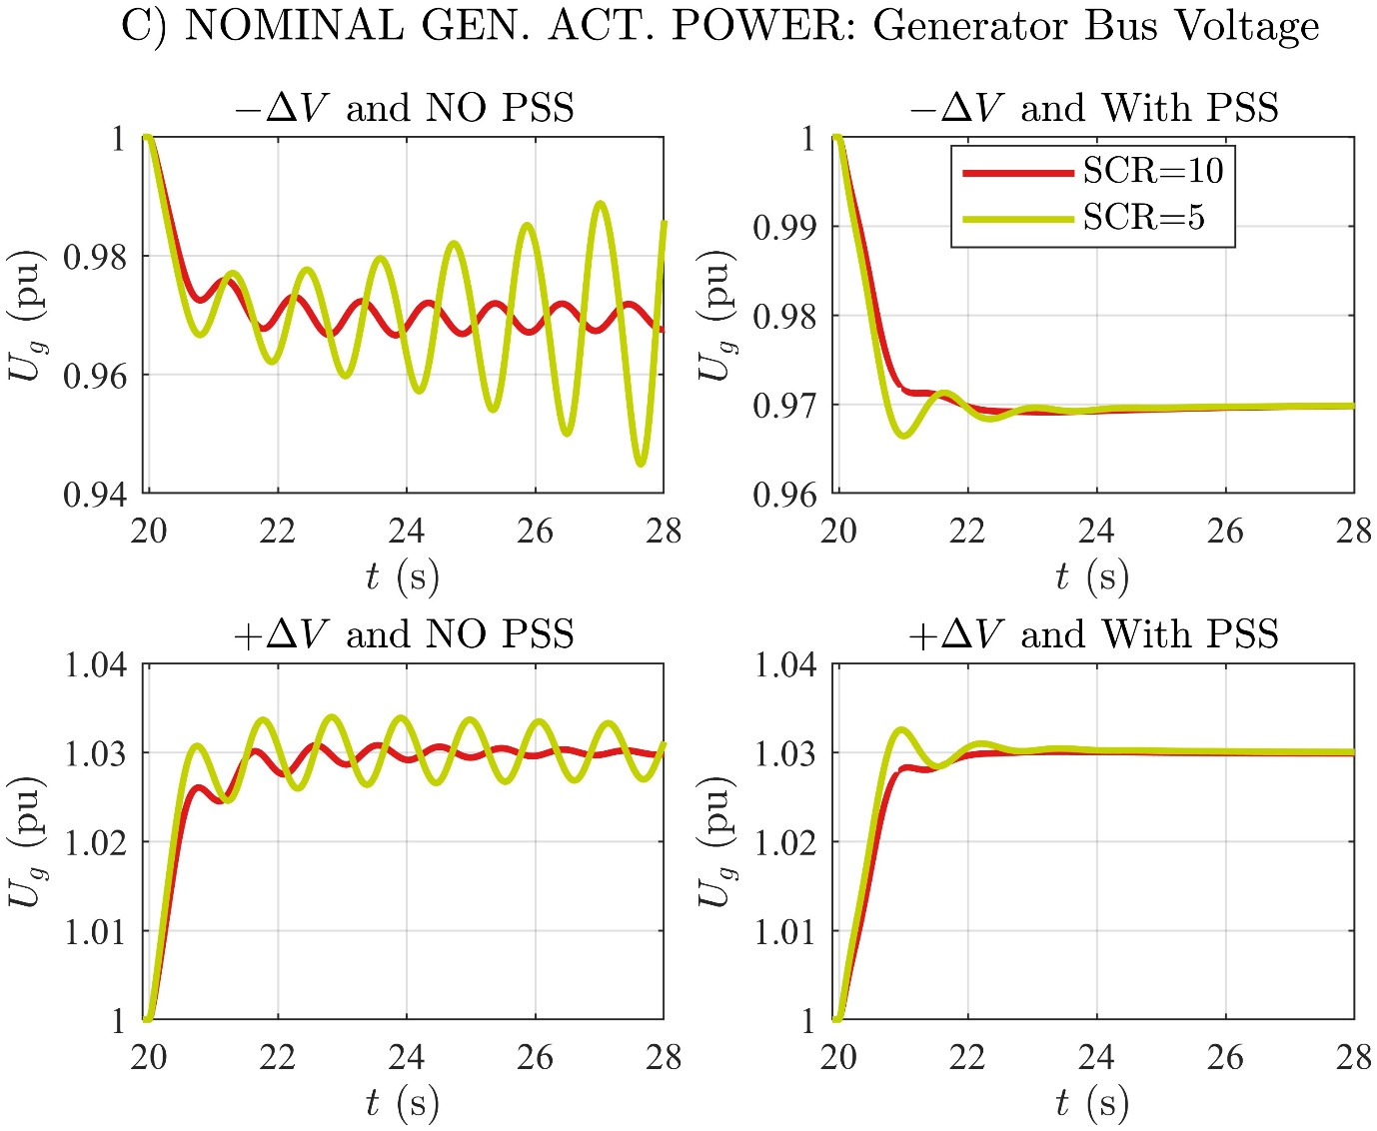

# C) NOMINAL GEN. ACT. POWER: Active Power

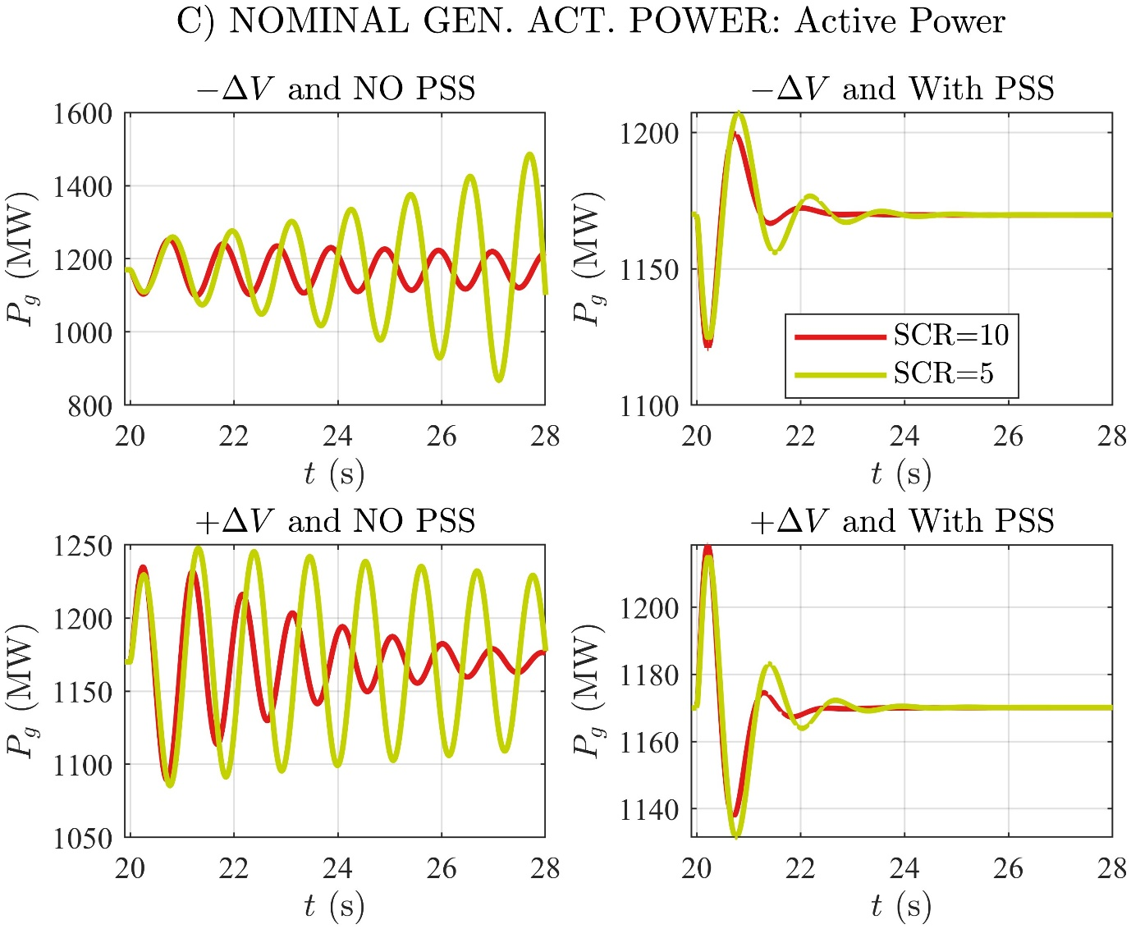

# C) NOMINAL GEN. ACT. POWER: Reactive Power

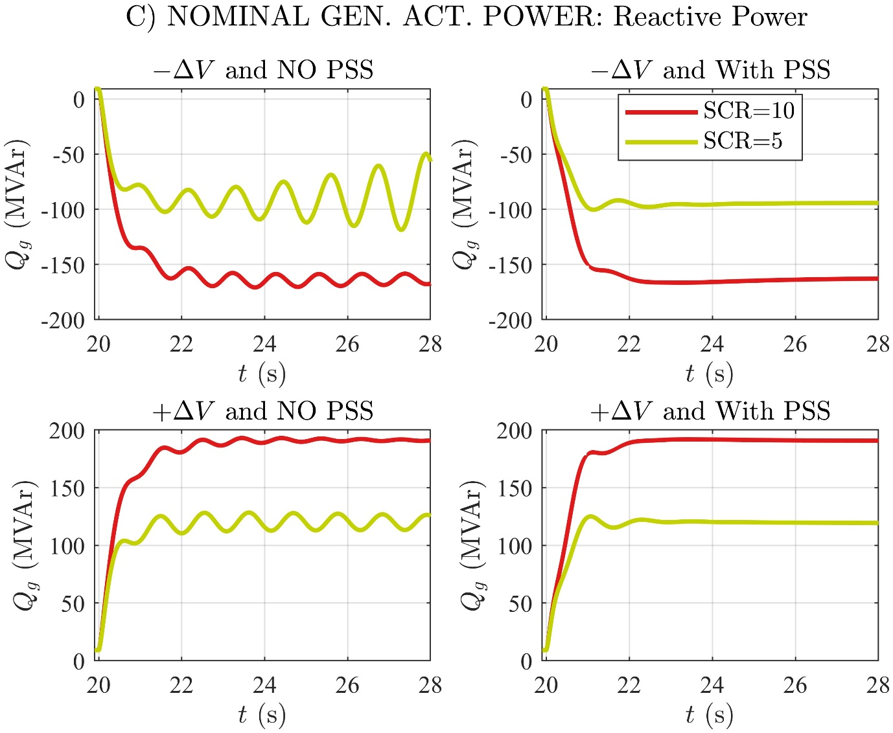

# C) NOMINAL GEN. ACT. POWER: Generator Stator Current

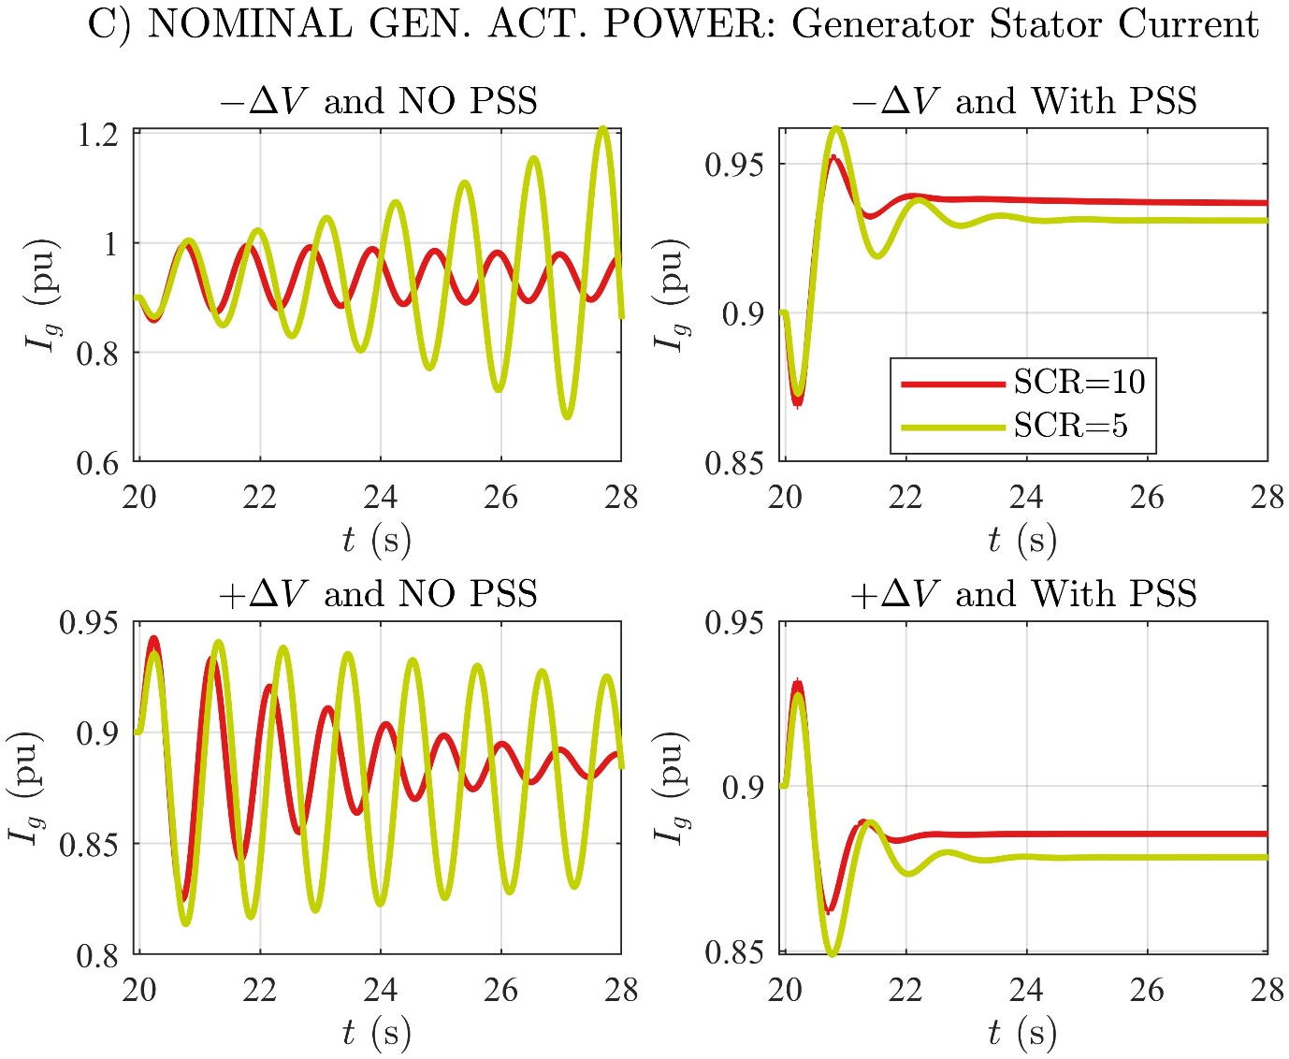

# C) NOMINAL GEN. ACT. POWER: Excitation Voltage

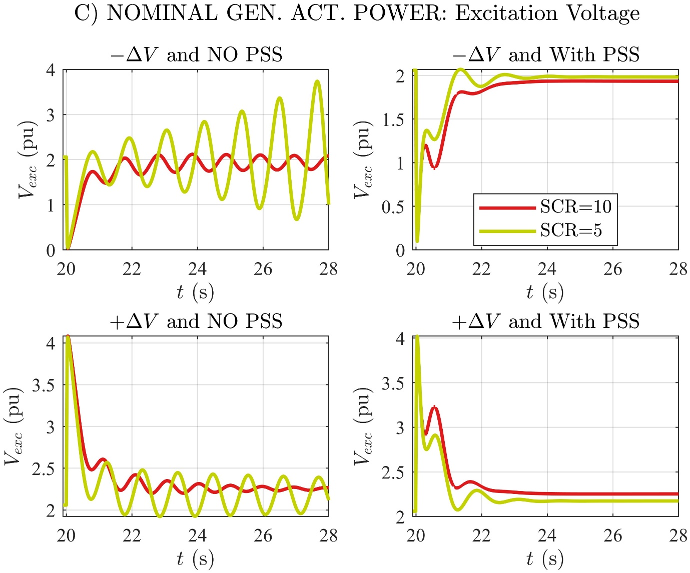

# C) NOMINAL GEN. ACT. POWER: Excitation Current

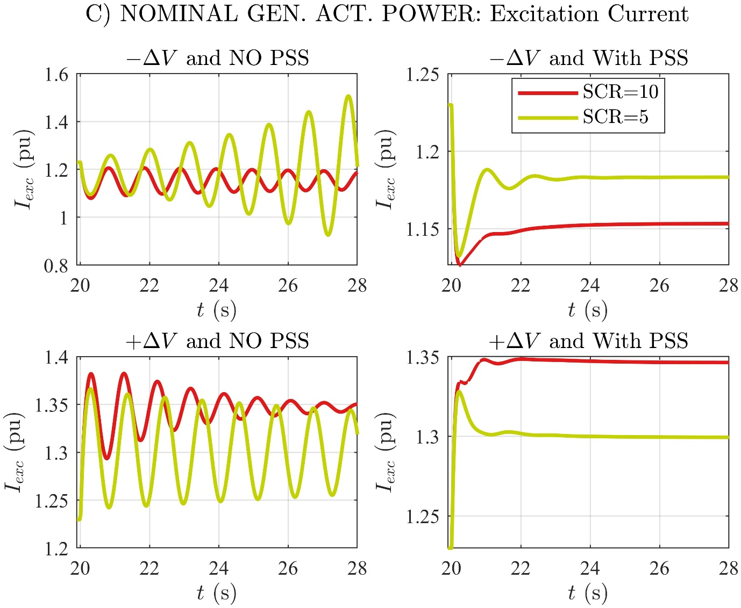

# C) NOMINAL GEN. ACT. POWER: Generator Speed

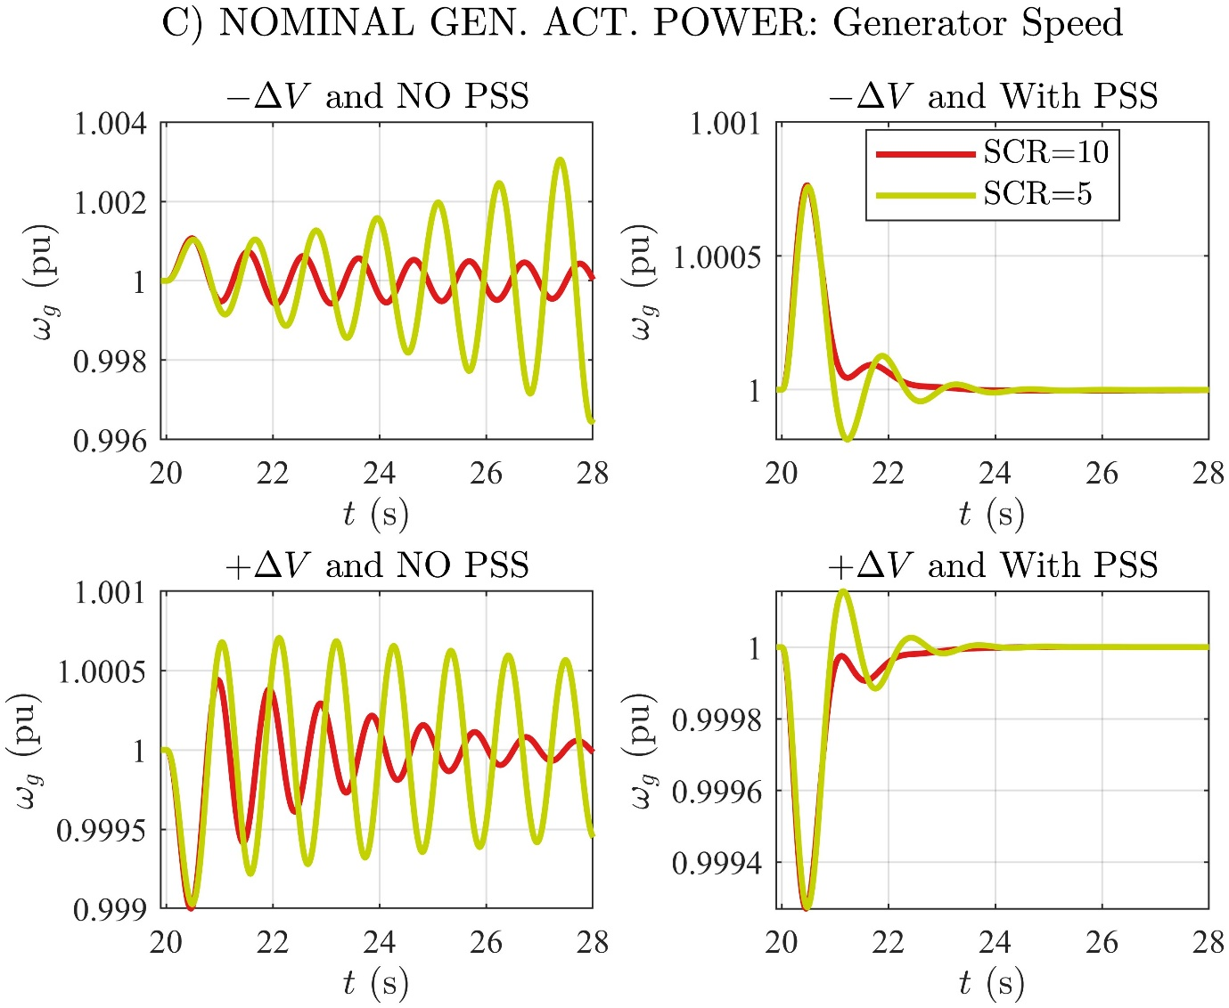

# C) NOMINAL GEN. ACT. POWER: Gen. Frequency Deviation

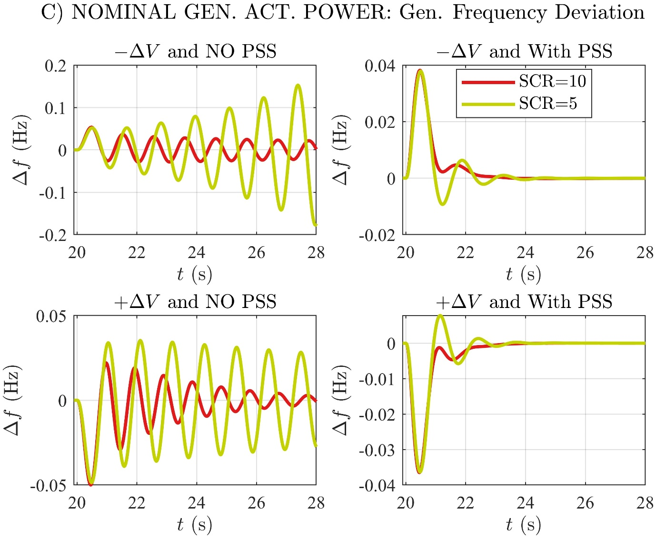

# C) NOMINAL GEN. ACT. POWER: Ext. Rotor Angle

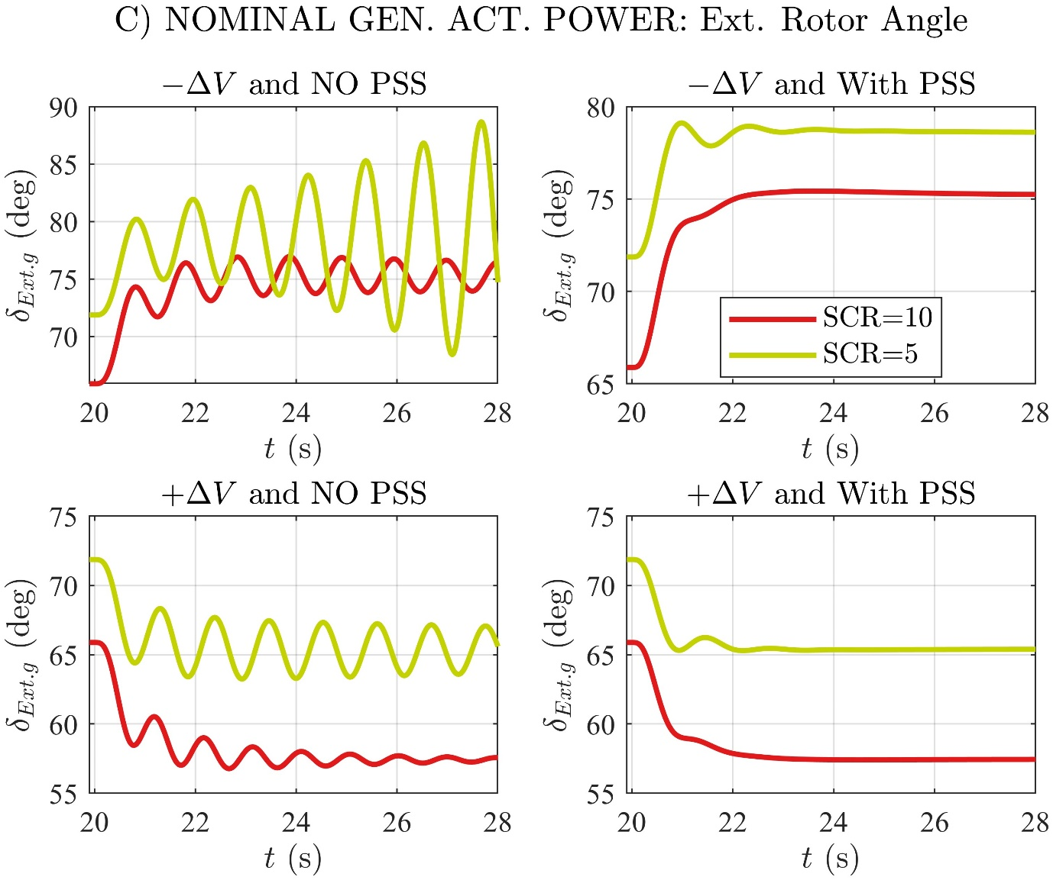

# C) NOMINAL GEN. ACT. POWER: Int. Rotor Angle

